BACK PAGE

Worship Leader for Today: Rev Gary Stuckey Lectionary for Today: **6 June 2021:** **I Sm 15: 34 - 16: 13; Ps 20; 2 Cor 5: 6 - 10, 14 - 17; Mk 4:** **26 - 34.**  Reminder for Stewards: 13 June2021 Dennis Wood Bob Heywood

**-**

**Welcome to our Church**.

Things you need to know, especially if you are a visitor. **Fire exits** are marked. Please take note. In the case of an emergency evacuation please gather on the Western Lawns under the Pine Tree. **St John First Aid Kit** - on top of the pigeon holes up from the ramp. **Toilets** are available through the door front right of the Worship Area or out through the turn around point on the ramp. **Morning tea** is held after the service – we hope you will join with us. According to our **Covid plan**, please note the seating arrangements within the building for your safety.

**Items for the Newsletter**

Please email items to [newsletter@seacliffuc.org](mailto:newsletter@seacliffuc.org) by 5pm on Wednesdays. If you do not have access to email, please phone or call in at the church office and it will be forwarded for you.

**Our Minister is Rev. Gary Stuckey.**

**Contact :**

Mobile : 0488 017 187, Home phone : 8270.2862

email : minister@seacliffuc.org

**Church Office Information**

Phone / Email contact only Thursday and Friday

9.30am – 12.30pm

🕿 8296 1517

Email: office@seacliffuc.org

Website: www.seacliffuc.net



**Uniting Church in Australia**

### *SEACLIFF WEEKLY NEWS*

### Sunday 13 June 2021

### PENTECOST 3

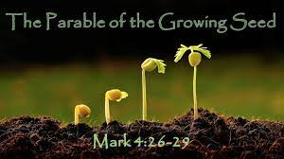**The Parable of the Growing Seed** 26He also said, “This is what the kingdom of God is like. A man scatters seed on the ground. 27Night and day, whether he sleeps or gets up, the seed sprouts and grows, though he does not know how. 28All by itself the soil produces grain—first the stalk, then the head, then the full kernel in the head. 29As soon as the grain is ripe, he puts the sickle to it, because the harvest has come.” **The Parable of the Mustard Seed** 30Again he said, “What shall we say the kingdom of God is like, or what parable shall we use to describe it? 31It is like a mustard seed, which is the smallest of all seeds on earth. 32Yet when planted, it grows and becomes the largest of all garden plants, with such big branches that the birds can perch in its shade.” 33With many similar parables Jesus spoke the word to them, as much as they could understand. 34He did not say anything to them without using a parable. But when he was alone with his own disciples, he explained everything. **Mark 4: 26 – 34**

**This Week at Seacliff**

**Big Book Sale Today 11am to 4pm, Mon. 11am to 3pm.**

**Men’s Dinner 6.30pm Wednesday 16th June**

**What’s News**

**Discovering Meditation** - Seacliff Uniting Church,

Three sessions remaining for June: Tuesday morning, June 15 at 10:30am, Wednesday evening, June 16 at 7:30pm, Thursday afternoon, June 17 at 2:00pm. Gary

**Contemplative Worship**

It seems that we are living in an increasingly busy, noisy and fast paced world. Where and how can we find some peace and quiet?

One way is in Contemplative Worship, a service of stillness, silence and reflection.

The next Contemplative Worship will be at Seacliff UC **on June 27th**. It will commence at 6:00pm and run for about an hour, followed by light refreshments for those who wish to stay and mingle.

The service will include quiet music, often from the Taize community, readings, a short reflection followed by a period for personal reflection in silence, Holy Communion and prayer.

This is an opportunity to come into the quiet and find grace and peace to restore your soul.

If you have any questions please contact Rev Gary Stuckey (0488 017 187) or [gstu@internode.on.net](mailto:gstu@internode.on.net)

**Circle of Friends**

As you may recall at a meeting earlier in the year Seacliff UC voted to support work with refugees through the Circle of Friends as one of its mission projects for this year.

On Sunday 27th June, we will have the opportunity to learn more about this project when Sr. Meredith Evans will be our guest. She will speak in our morning worship and after morning tea (about 11am), for those who wish to stay, she will speak further and answer questions. Gary Stuckey (Rev)

**Seacliff’s Mission Appeals**

***Oodnadatta Faith Community, Circle of Friends Adelaide, UCCP United Church of Christ in the Philippines***

You may recall that we decided as a congregation to support these three projects through our Mission Appeals this year (in addition to continuing to support “We Dream” in Bangla Desh).

We have been significantly pre-occupied this year until now, but the time has now come to give our attention to these projects. Traditionally the first Sunday each month has been the time when we particularly remember our Mission Projects and support them.

Information about these projects was placed on the wall of the middle hall for the centenary weekend. I can add that $40 000 has been raised in total for the Oodnadatta project so far, and they are at the point of drawing up plans for a building.

So this is an invitation, and encouragement, to all of us to make a significant contribution to our Mission Projects across the remainder of this year, as a demonstration of both encouragement and practical support for the needs of the people involved.

Thank you in anticipation. Max

**Disaster and Recovery Ministries Training Days**

On **Tuesday 22nd and Wednesday 23rd June** Seacliff Uniting Church congregation are hosting training sessions arranged by the Disaster and Recovery Ministries who train and coordinate teams of people to provide pastoral and spiritual support to disaster-affected people.

Volunteers are required to provide refreshments, including a light luncheon, for participants involved in the training sessions. If you can support or help with the catering on these 2 training days please contact Annette (0438664100)

**Presbytery Secretary      Presbytery of Southern SA**

The Presbytery of Southern SA seeks to appoint a secretary to serve the continuing work of the Presbytery – taking office as soon as possible and in any case from Sept 17th, 2021. The position is offered for a 2-year term in the first instance, with the possibility of extension.

 We seek a person comfortable working with people and managing correspondence, with good communication skills including possessing appropriate document management and IT skills, and with some working knowledge of “how the Church works”.

This is an important leadership role within the Presbytery, both assisting the Chairperson in the conducting of the work of the Presbytery and providing secretarial services to the Presbytery.

It is a requirement that the Secretary be a member of the UCA.

Further information, including a full position description, may be obtained from current secretary Max Howland at  [southern.secretary@sa.uca.org.au](mailto:southern.secretary@sa.uca.org.au) , or on 0414 910 419. The position may be filled on either a volunteer basis or a stipended basis. Rosemary

**Men’s Dinner**

The June **Mens’s Dinner** is booked for **16th June** with the venue the **Vines Golf Club**. Location is on the corner of Reynell Road and Mark Street, Happy Valley. Meet at 6.30pm for a 7pm start. For information or transport, contact Ray on 8298 3480.

**Cogs n’ Coffee**

Twelve hardy riders braved the cold Southerly and road from Pt Elliot to the Bluff and back, it was great riding back. At midpoint on the ride the riders joined eight others for lunch at the Boulevard Cafe, a great time with the opportunity to catch up with Athalie and Ross Ford.

Meet at Warradale shope at 8.30am for next werks ride to Pt Adelaide to take in the tour of Wall Art, allow a bit longer as there are 32 paintings over a 6k route, a light lunch would work. Brian

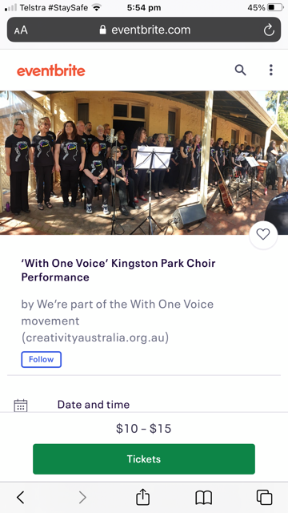**‘With One Voice’ Kingston Park Choir**

This group will be performing at the Kauri Community and Sports Centre, Lipson Avenue Seacliff, SA Sun 27/06/2021 at 2:30 pm - 5:00 pm | Eventbrite Tickets $10 – $15.

**We would love you to join us for an afternoon of singing. Afternoon tea is included in your ticket.**

## **About this event**

We’re part of the With One Voice movement (creativityaustralia.org.au). A network of 30 choirs across Australia committed to strengthening communities and inspiring individuals to find their voice.

https://www.eventbrite.com/e/with-one-voice-kingston-park-choir-performance-tickets-158271469225

Marilyn W.